**NAME: ALI GHULAM MURTAZA**

**ROLL NO: SFI-24S-001**

LAB NO: 2

**TASK NO 1: Print numbers from 1 to 10 using a for loop.**

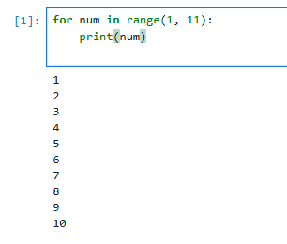

**TASK NO 2: Print all even numbers between 1 and 20 using a while loop.**

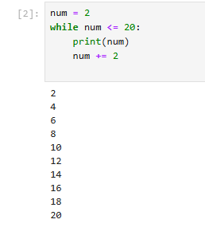

**TASK NO 3: Calculate the sum of numbers from 1 to 100 using a loop.**

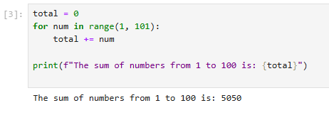

**TASK NO 4: Print the multiplication table of 5 using a loop.**

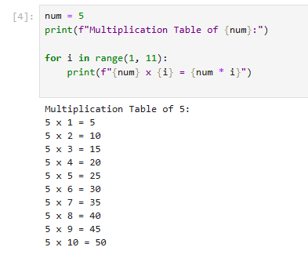

**TASK NO 5: Find the factorial of a given number using a for loop.**

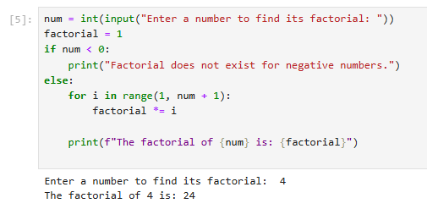

**TASK NO 6: Create a list of numbers and print only the odd numbers using a loop.**

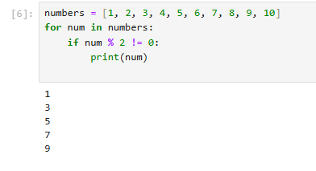

**TASK NO 7: Iterate over a list of fruits and print each item.**

